Almost There Assessment 1: EE1-EE4 (Standard Plus)
Name___________________________________ Date ___________________ Block #_____
Show ALL of your work for full credit!! Use CUBES for all word problems. Your final answer MUST be on the answer line. DO YOUR BEST!!!!
Novice (0% - 59%) Apprentice (60% - 74%) Practitioner (75% - 89%) Expert (90% - 100%)

Grade for 6.EE.1 (exponents) Grade for 6.EE.2 (expressions)

Grade for 6.EE.3 (distributive property) Grade for 6.EE.4 (combining like terms)

1) 6.EE.1 Gridded Response:  Evaluate the following: 2⁵ • 6⁶  2³ • 6⁴  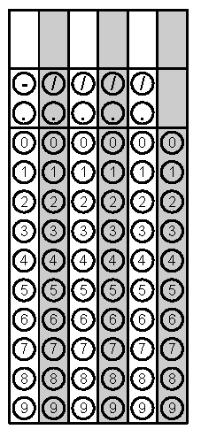 | Work
2) 6.EE.2  Evaluate the following when a = 5 and c = 1.  a + 6(3^{c} – 0) ÷ 3²  Answer _______________ | Work
3) 6.EE.2  Write an algebraic expression that represents fifteen fewer than three times a number.  Answer: _______________ | Work
4) 6.EE.3  Use the distributive property to produce an equivalent expression for 3(5x - 8).  Answer________________ | Work
5) 6.EE.4  Simplify the following expression: 14x + 7 – x – 2.  Answer: __________________ | Work

Almost There Assessment 1: EE1-EE4 (Honors)
Name____________________________________ Date __________________ Block #_____
Show ALL of your work for full credit!! Use CUBES for all word problems. Your final answer MUST be on the answer line. DO YOUR BEST!!!!
Novice (0% - 59%) Apprentice (60% - 74%) Practitioner (75% - 89%) Expert (90% - 100%)

Grade for 6.EE.1 (exponents) Grade for 6.EE.2 (expressions)

Grade for 6.EE.3 (distributive property) Grade for 6.EE.4 (combining like terms)

1) 6.EE.1 Gridded Response:  Luke ran (2/4)³ miles in January. How many miles did he run? | Work
2) 6.EE.2  Evaluate the following when a = 15, b = 24, and c = 3.  a + 6(3^{c} – b) ÷ 3²  Answer _______________ | Work
3) 6.EE.2  Write an algebraic expression that represents fourteen less than the product of six times a number squared.  Answer: _______________ | Work
4) 6.EE.3  Use the distributive property to produce an equivalent expression for -6(3x – 2/3).  Answer________________ | Work
5) 6.EE.4  Combine like terms to simplify the following.  –9(m + 5) – 2m  Answer: __________________ | Work

