Solving One Step Equations Notes: Addition and Subtraction

- An equation is a statement that two ___________________ are ____________. The amount on one side of equal sign must have the same value as other side.
  - Example: 5+3 = 6+2 5+3 =
__ = __ 6+2=
Both sides of the equation = ___. So this equation is true!

Steps to balance an equation
- __________________ the variable
2. Use the __________________ operation to isolate
3. ___________________ your answer

Inverses
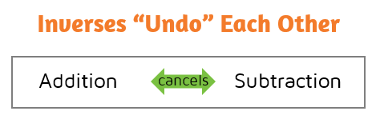
- Inverse operations ____________
each other out!
- Practice - Write the inverse:
- +3 _____
- -4 _____
- -10 _____
- +7 _____

Equations with Addition Equations with Subtraction

x + 2 = 7 x - 3 = 6

x = x =

Check your answer: Check your answer:

