Solving One Step Equations Notes: Multiplication and Division

- An equation is a statement that two ___________________ are ____________. The amount on one side of equal sign must have the same value as other side.
  - Example: 6-2 = 3+1 6-2 =
__ = __ 3+1=
Both sides of the equation = ___. So this equation is true!

Steps to balance an equation
- __________________ the variable
2. Use the __________________ operation to isolate
3. ___________________ your answer

Inverses
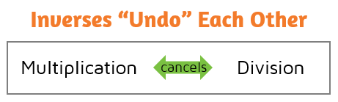
- Inverse operations ____________
each other out!
- Practice - Write the inverse:
- x3 _____
- ÷4 _____
- ÷10 _____
- x7 _____

Equations with Multiplication Equations with Division

3x = 12 x/2 = 5

x = x =

Check your answer: Check your answer:

