Name: _____________________________________
Homework (WEEK 6) Honors:
TRY YOUR BEST AND SHOW ALL OF YOUR WORK! Use CUBES (circle, underline, box, evaluate, and solve) to earn full credit.
MONDAY:
Solve the following problems without a calculator. You MUST show your work. NO WORK = NO CREDIT.
- 55. The Reyes family is going to the mall. When they leave home, the car odometer reads 54,362 miles. When they arrive at the mall 15 minutes later, the odometer reads 54,372 miles. What was their average speed in miles per hour? Use a table to organize your answers.  Miles  minutes  2. John and Rosie own a home assessed at 98,000. If for every $1000 of assessed value they must pay $65.50 in taxes, how much is their tax bill?  Answer: _____________ | 3. Translate the words into algebraic expressions.  - The quotient of three times a number and six  Answer: _____________  - The one number multiplied by itself five times  Answer: _____________  - Four times a number decreased by the quotient of ten and two  Answer: _____________  4.Compare the number of triangles and circles. If the ratio remains the same, how many triangles will there be if there are 40 circles?  ▲▲▲▲▲▲▲ ● ● ● ● ● ● ● ● ● ● ●  Triangles 7 35 21 70 ?  Circles 11 55 33 110 88
5. Instant Meals sent out free samples to introduce its new product, Sesame soup. Each sample weighs 69 ounces. The post office charges thirty-six cents for every 23 ounces of weight. How much would Instant Meals spend on postage to mail out one hundred eighty-eight samples? Include the $ sign. | 6. There is a jar on the cabinet by the refrigerator. If Keona pours 114 ounces of water into the jar three times to fill it, how many quarts of water does it take to fill the jar? Round your answer to the nearest whole number. (Hint: 32 ounces = 1 quart)
TUESDAY:
Directions: Solve the following problems. You MUST show your work. NO WORK = NO CREDIT.
1. Mr. Edward is going shopping for new pants and shirts. The sales tax where he lives is 6.25%. He gets a $2-off coupon for every $20 he spends at the mall. How much would Mr. Edwards need to spend to get $12 off in coupons?  Answer: _____________ | 2. Mrs. Ling rents space at the mall where she sells sunglasses. She must pay the mall $50 everyday, plus $6 for every $125 in sales. Today, she paid the mall $92. What were her sales today? a. Can you use the ratio 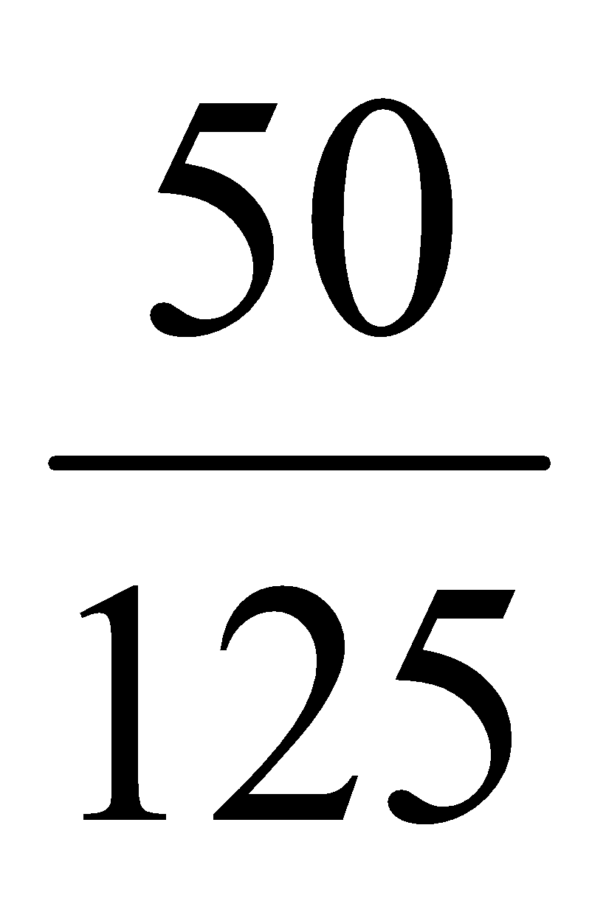to solve this problem? Why or why not?
3. A blue whale was once recorded with a length of 36 yards. How many centimeter long was the whale, if 1in = 2.54 cm?  Answer: _____________ | - Solve the following expression:  7( $$\frac{1}{2}$$ + 2) – 2⁰ + 3 ( $$\frac{1}{2}$$ ) =
WEDNESDAY:
Directions: Solve the following problems. You MUST show your work. NO WORK = NO CREDIT.
- Evaluate the following if g = 6, m = 2, and d = 8.  - gm³ + 2d =  - md + 4(g + 4) =  m³  - 12d – gm = | - Which property was used to simplify this expression?  3y + 42x + 7y – 5x  3y + 7y + 42x - 5x  10y + 37x  3. An 21-cartoon pack of juice cost $6.89. At the same rate, how much will an 8-cartoon pack cost?  Answer: _____________
4. How many centimeters are in 10 feet, given that 1-inch ≈ 2.54 cm.  Answer: _____________ | 5. Brad’s father asked an engineer to survey the filed behind their house. He wanted to plant some orange and tangerine trees there. According to the survey, the filed is thirty-two feet long and six yards wide. What is the perimeter and area of the filed in centimeters?  Answer: ____________
THURSDAY:
Directions: Solve the following problems. You MUST show your work. NO WORK = NO CREDIT.e:
1. Evaluate.  - 2³ • 7⁵  2 • 7³  Answer: _____________  - (3.5 • 5)³  Answer: _____________ | 2. Using the information in the table, find the number of yards in 72 feet.  Feet 4 8 12 20 72  Yards 1 2 3 5 ?  Answer: _____________
3. Jamie scored x points in a class game. If Dede scored 3 points for every point Jamie scored, write an algebraic expression that shows the amount of points Dede scored.  Answer: _____________ | 4. Lizzy saw a raccoon in her backyard last weekend. She put out some water and a bowl with 3 cups of food. The raccoon drank all the water and ate ½ the food. How many ounces of food did the raccoon eat?  Answer: _____________

