Name________________________________________________________
Homework (WEEK 4) S+:
TRY YOUR BEST AND SHOW ALL OF YOUR WORK! Use CUBES (circle, underline, box, evaluate, and solve) to earn full credit.
MONDAY:
Solve the following problems without a calculator. You MUST show your work. NO WORK = NO CREDIT.
- Place one set of parentheses in the correct place to make the statement true.  - 10 + 3 • 4 + 12 = 58  - 10 + 3 • 4 + 12 = 64  - 10 + 3 • 4 + 12 = 34 | - Explain in complete sentences where and why Mrs. Miele went wrong when solving this problem.  Step 1:  (27⁰ • 8²)  2(4² ÷ 2)  Step 2:  27 • 16  2(8 ÷ 2)  Step 3:  432_ = 432  2(4) 8
- It was a cold winter day in Charlotte with a record low of 8 degrees. When the sun went behind the clouds it dropped twelve degrees. What was the temperature at night? (Hint: Draw a number line.) | - Write the following in expanded form and solve.  - 6³  - 5⁴  - 2⁹  - 6⁰
TUESDAY:
Directions: Solve the following problems. You MUST show your work. NO WORK = NO CREDIT.
- Solve.  - • 3 – 8)² ÷ 4(5² ÷ 5)  - 240 ÷ 6 + 553 ÷ 7 • 2 | - 4, 560 ÷ 12 =  - Evaluate:  - 6³ + 9²  - 8³ – 2³
- Edwin’s mom gave him $60 to purchase items at Sport’s World. Edwin bought four baseballs that cost $5.52 each and two hats that cost $12.39 each. How much did Edwin spend on baseball hats? How much change did he have after his purchase? | - Solve.  1000⁰ + 5² + 4³ • 1⁹  63¹ • 3⁶ =
WEDNESDAY:
Directions: Solve the following problems. You MUST show your work. NO WORK = NO CREDIT.
- Evaluate: 12² + 5 + 7(2) ∙ 12⁰ – 3⁴ + 10³ | - Evaluate: 5² ÷ (25 ÷ 5) ²  3. 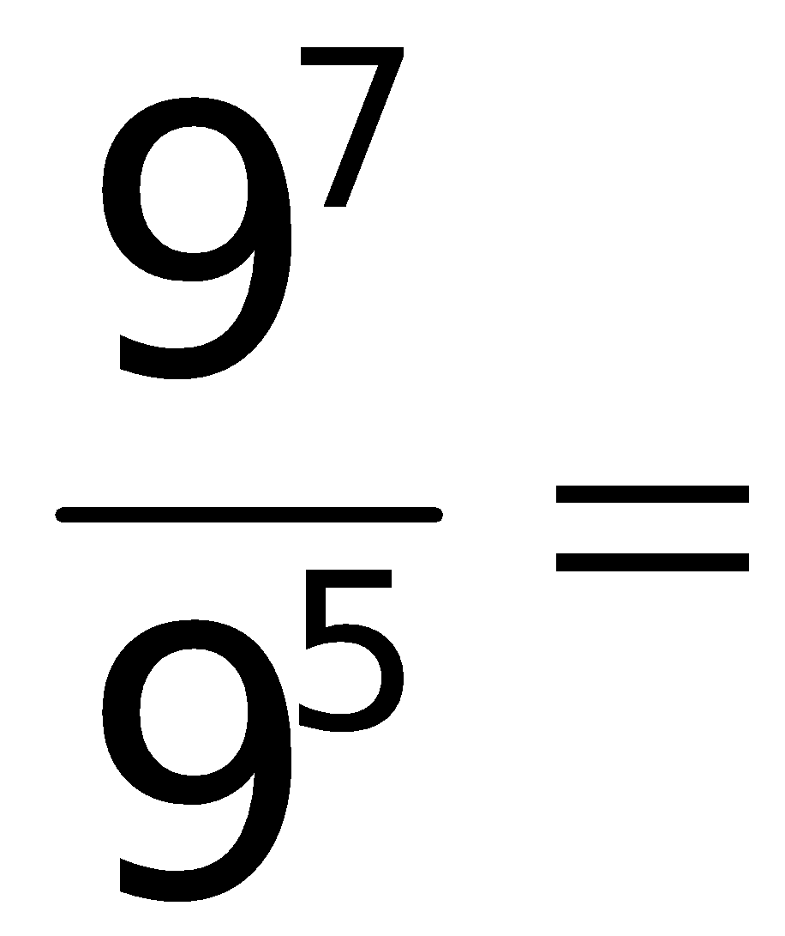
4.Solve the following:  (9⁰ + 3)³ – 6(72÷9) + 12  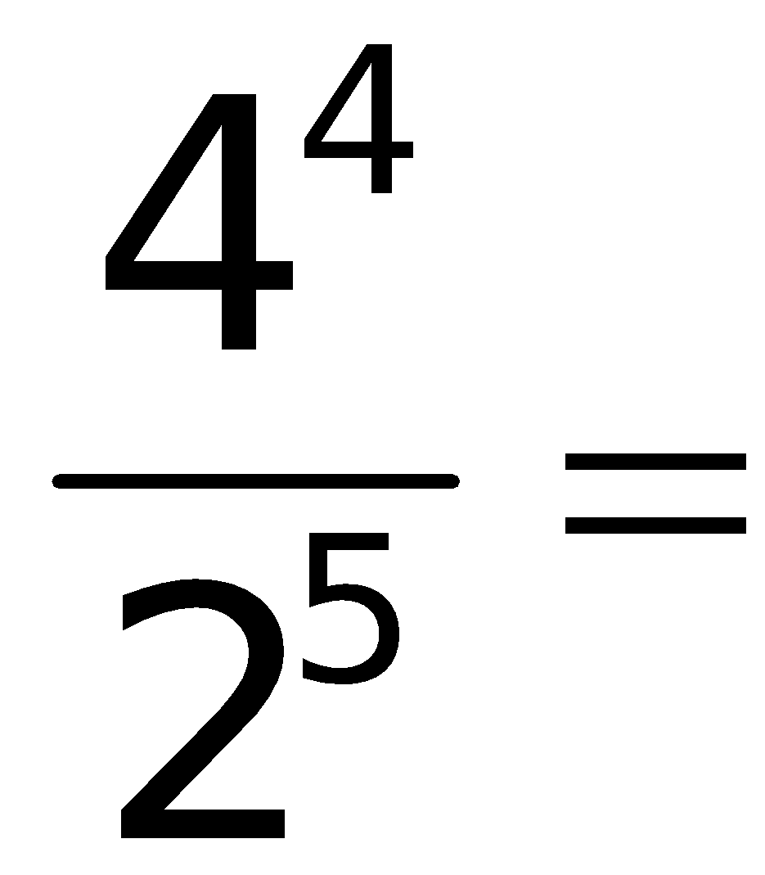 | 6.Solve.  12² – 5(3 • 3 + 3)  2
THURSDAY:
Directions: Solve the following problems. You MUST show your work. NO WORK = NO CREDIT.
- Evaluate:  (199⁰ • 9²)  3(3³ ÷ 3) | - List the first 10 multiples of each number:  - 9  - 12  - 6
- Simplify and solve.  8⁴• 9³  8³•9²  - ^{Evaluate.}  37 + – 4(12)  3( 8 + 2) ÷ 5 - 4 | - Jeremy picks up pennies every day. He picked up two pennies on the first day. He picked up twice as many pennies the next day. He picked up twice as many pennies the 3rd day as he did the 2nd day and so on. In exponential form, write an expression to find the number of pennies he picked up on the 5th day.

Name________________________________________________________
Friday
Directions: Solve the following problems. You MUST show your work. NO WORK = NO CREDIT.
- Solve.  (6 • 3 – 8)² ÷ 4(5² ÷ 5)  5³ ÷ (5² • 5) | - Evaluate.  4³ • 3³  2⁴ ÷ 4⁰
- In the list of numbers below, put a around the prime numbers and put a around the composite numbers.  11 24 33 51 27 99 91  63 31 25 43 57 1 54 | - Solve.  (6•4÷3)² – (2⁴ – 5 •2)

Weekend Homework
Directions: Solve the following problems. You MUST show your work. NO WORK = NO CREDIT.
- Using the divisibility rules, state what each number is divisible by (using the rules for 2, 3, 5, and 10) and EXPLAIN WHY.  - 57  - 47  - 690 | - Kyrel wrote 64 as 8 • 2. What did he do wrong?  - Write the following in exponential form:  c • c • c • v • v • v • 6 • 6 • 6  w • w • w • w • w • w • w • w • w  ½ • ½ • ½ • ½
- There are 117 people in the cooking class. Everyone has to buy 1 dozen eggs. How many eggs will the class have in total?  - The art teacher is cutting kite string from a 100-foot-long piece of thread by cutting it into as many 15-foot-long sections as possible. How many feet of rope will be left over? | - Evaluate.  - (6² ÷ 9)³  - Pat owns a car wash business. She charges $13 to wash and wax a car. She serviced 145 cars last week. What was her profit for the week?

