Name: _____________________________________
Homework (WEEK 7) Honors:
TRY YOUR BEST AND SHOW ALL OF YOUR WORK! Use CUBES (circle, underline, box, evaluate, and solve) to earn full credit.
MONDAY:
Solve the following problems without a calculator. You MUST show your work. NO WORK = NO CREDIT.
- Write an algebraic expression for the following:  - Twice a number decreased by 8 ___________  - The sum of 5 and a number increased by 6 _____________  - A number squared more than 4 ___________  - d. 8 less than a number of elephants _______ | 2. What is the value of:  - 0.4³ = __________  - 5 + 2⁴∙ 6 ÷ 6= __________  - 6² + 25x ÷ 5 • 2 + 6.78⁰ • x __________  If x=3
3.A rectangle has a length of 3x and a width of  x + 4. The rectangle’s perimeter is: __________  The rectangle’s area is: __________  A square has a side length of 6y². What is the perimeter of the square? ______ | 4.Underline key words and write an algebraic expression for the following phrases:  - fourteen decreased by a number p _____________  - the product of a number and 6 _________________  - nine more than the number of math assignments  ________________________
TUESDAY:
Directions: Solve the following problems. You MUST show your work. NO WORK = NO CREDIT.
- 5y + 4 (You can NOT say 5y plus 4. Think of another way to translate this expression)  __________________________________________ | 2. Write an algebraic expression to represent the following:  a) The sum of a number and the quantity two times a number minus one.  ________________  b) Seven divided by the sum of a number plus 2.  _________________  c) The quantity six plus a number divided by two.  __________________  d) Triple the difference between a number and 7.  ___________________
3. Write a mathematical story for the following equation.  15b = 180  ____________________________________________  ____________________________________________  ____________________________________________ | 3. Solve.  (6 • 4 ÷ 3)² – (2⁴ – 5 • 2)  Answer ___________
WEDNESDAY:
Directions: Solve the following problems. You MUST show your work. NO WORK = NO CREDIT.
- _{Solve the equation for x.}  a) 3x + 10 = 15 x = ______  b) 4x – 8 = 8 x = _______  c) 5x + 1 = 16 x = _______ | 2. Evaluate the expression 3x² + 2y ÷ 2 when x is equal to 4 and y is equal to 2.4.  Answer: ______________________  3. Evaluate 5(n² + 3) – 7n, when n= ¼  Answer: ______________________
3. Evaluate the following expression when x = ½ and y =3  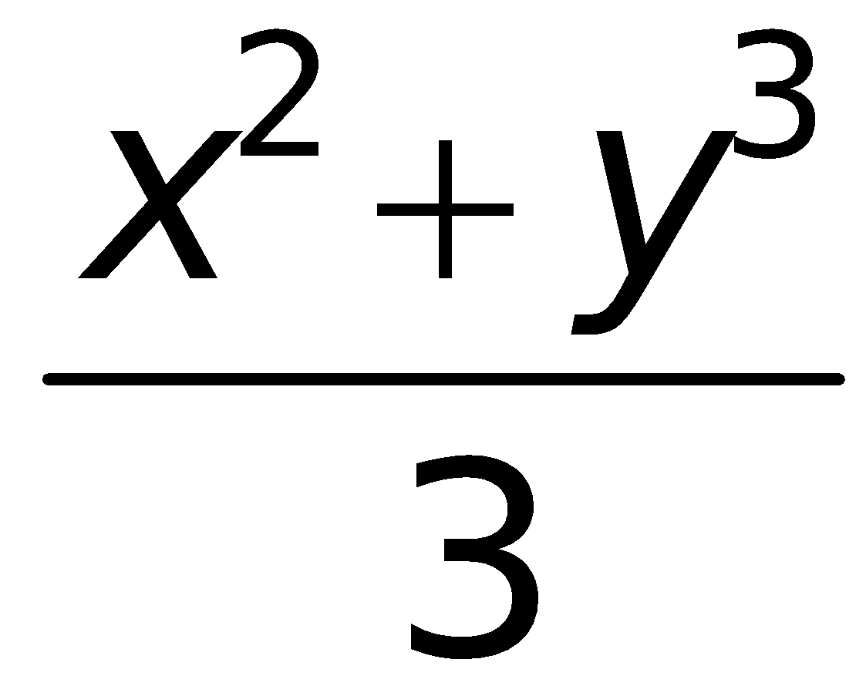  Answer: ______________________  4.  $$\frac{x^{2}- 2y + 3(z-1)}{y}$$when x = 6, y = 12 and z = 5  Answer _______________ | 5. Given that the width is 6 units and the length can be represented by x² + 6, what is the area of the flowers below?  x² 6  6  Answer: ______________________
THURSDAY:
Directions: Solve the following problems. You MUST show your work. NO WORK = NO CREDIT:

- Simplify the following expression:  -20w – 4x + 3w – 8 + 42x ÷ 7  Answer _______________  - Use the distributive property to produce an equivalent expression for  21x ÷ 3 + 6(3 – x) + 7⁰  Answer _______________ | 5. Simplify the following expressions.  12r + 6(4r – 3) + 5² – 9r²  Answer _______________  6. 6(4x – 2) – 9x + 4²  Answer _______________
3. Evaluate:  6xy when x = 3.7 and y = 11  Answer _______________ | 7. Write the following algebraic expressions in word form. 8(2z – 4) ______________________________________

