Name: __________________________
Homework (WEEK 9) S+
TRY YOUR BEST AND SHOW ALL OF YOUR WORK! Use CUBES (circle, underline, box, evaluate, and solve) to earn full credit.
MONDAY:
Directions: Solve the following problems. You MUST show your work. NO WORK = NO CREDIT.
- Simplify the following expressions:  - _{8 + 3(x – 2) + 4x}  - _{9y + 4x + y + 3(2x)}  ₂ | - Solve and graph the solutions on a number line.  - 4x = 20  - $$\frac{x}{7}$$ = 3
- Insert <, > or = to compare the fractions:  - $$\frac{3}{5}$$ ______ $$\frac{5}{9}$$  - $$\frac{2}{7}$$ ______ $$\frac{4}{11}$$ | - Royal and Niam go to an amusement park. Niam spends ½ of his money, and Royal spends ¼ of his money. Is it possible for Royal to have spent more money than Niam? Explain your reasoning.  Answer ________________________________________
TUESDAY:
Directions: Solve the following problems. You MUST show your work. NO WORK = NO CREDIT.
- It costs $10 to ship items across the U.S plus $4 per item. The expression 10 + 4i can be used to find the cost of any number of items, i.  If there are 12 items being shipped, how much would that cost?  _________________  If there are 9 items being shipped, how much would that cost?  _________________ | - Give a simplified expression to represent the perimeter of the figure.  3x + 8  2x -1 2x-1  3x + 8  Expression_________________________  If x has a value of 4, what is the perimeter of the figure?  Answer __________________________
- Mr. Campbell jogs 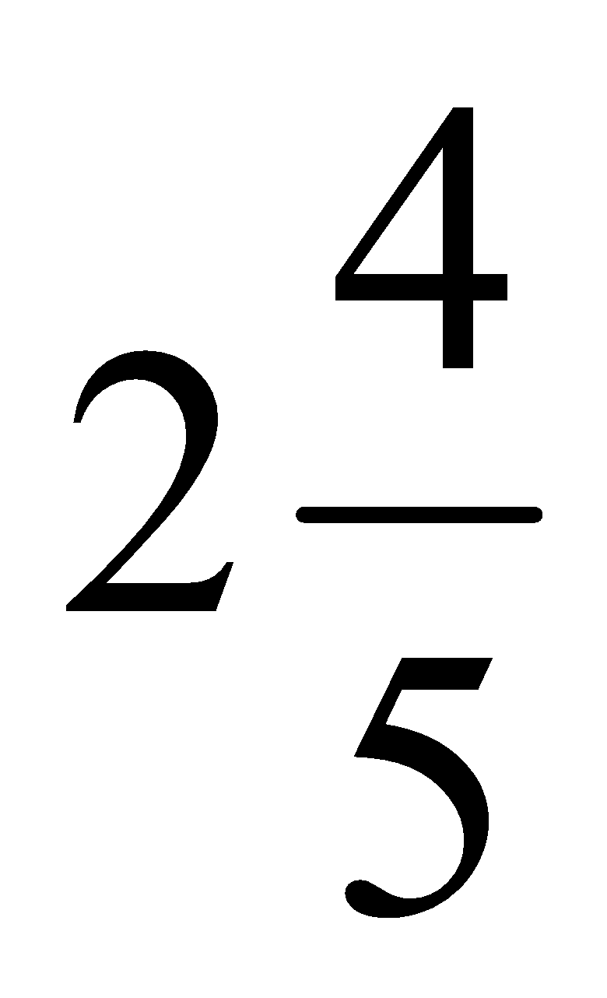km on a trail and then sits down to wait for his friend Mr. Hall. Mr. Hall has jogged 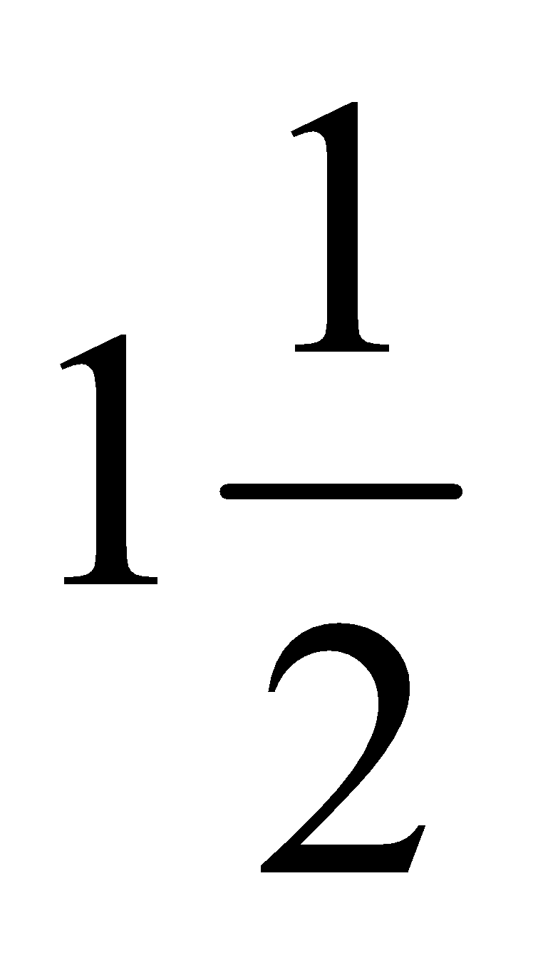km down the trail. How much farther will Mr. Hall have to jog to reach Mr. Campbell?  Answer ________________ | - Multiply the following fractions. Answers must be simplified.  - $$\frac{1}{2}$$ x $$\frac{3}{4}$$ = __________  - $$\frac{2}{3}$$ x $$\frac{1}{6}$$ = __________  - 4 x $$\frac{2}{7}$$ = __________  - $$\frac{4}{5}$$ x 8 = __________
WEDNESDAY:
Directions: Solve the following problems. You MUST show your work. NO WORK = NO CREDIT.
- Evaluate the following if a=10, b=5 and c=2:  - _{40/a + b}²  - _{5ac – 3(b + 4)}  - _{30/c - 2b + (a – c)}² | - Insert <, > or = to compare the fractions:  - 5³______ 4⁴  - 6³______ 5⁴
- Julius is ordering popcorn for his buddies at the movie theater. He has $20 and each bucket of popcorn costs $4.  a. Write and solve an inequality to find the maximum number of buckets he can buy.  b. Graph the solution on a number line. | - Solve each equation. Check your solution.  - m + 13 = 24  - n – 31 = 12  - 7u = 42  - $$\frac{w}{11}$$ = 4
THURSDAY:
Directions: Solve the following problems. You MUST show your work. NO WORK = NO CREDIT:
- List the property (associative, commutative, distributive, or identity) that the statement represents.  - 3(x + 2) = 3x + 6 ___________________  - 4 x 6 x 7 = 6 x 4 x 7 ___________________  - (9 + 2) + 1 = 9 + (2 + 1) _________________  - 5 x 1 = 5 ___________________  - 8 + 0 = 8 ___________________ | - The area of a triangle can be found using the expression $$\frac{bh}{2}$$, where b is the base and h is the height. Find the area of the triangle.  _______________________  14ft.  9ft.
3.The number of students at Ridge Road Middle School is 31 less than 2 times the number of students at Highland Creek Elementary. Create an expression that represents the amount of students at RRMS.  _________________________  How many students are there if 800 students attend the elementary school?_____________________ | 4. Create an equation that represents the relationship between x and y in the table. ___________  x 1 2 3 5  y 3 6 9 21  Fill in the entire table by using your equation.

