Name _____________________________________ Unit: 6.EE.5-9
Vocabulary Words | Definitions | Key Operations | Examples/Sentences/Visuals
equation | When two things are equal to each other (the left side is equal to the right side).
expression | When there are a combination of variables, constants, and coefficients
inequality | A relationship between two expressions that are not equal, often written with the symbols >, >, <, and < that mean greater than, greater than or equal, less than, less than or equal, respectively.
less than or equal to | A symbol used to indicate one number is smaller than or the same as another, with the smaller number given first. (For example 5 ≤ 9)
greater than or equal to | A symbol used to indicate one number is bigger or the same as another, with the bigger number given first. (For example 10 ≥ 4)
closed circle  (at least/at most) | When a value is equal to the given number  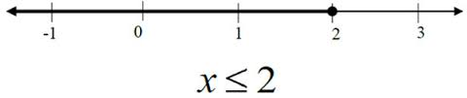
open circle  (more than/less than) | When a value is not equal to the given number  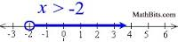
owe/below | Words that tell you to subtract numbers to the given number
exceed/profit | Words the tell you to add numbers to the given number
number line (graph) | A visual representation of the solution to an inequality or equation.

