Name _____________________________________ Unit: 6.G.1-3
Vocabulary Words | Definitions | Key Operations | Example/Sentence/ Visual
area | The surface included within a closed figure. (Multiply) Area of a rectangle is base x height. Area of a triangle is (b x h) / 2.
perimeter | The distance around the outside of a shape. (Add)
decompose | When a shape is broken apart into smaller shapes
volume | The space that is taken up by a 3-D shape. (Multiply) Volume of a prism is base x height x width
face | The side of a shape
base | The distance of the bottom of a shape
height | The distance from top to bottom of a shape
width | The distance from the front to back of a shape
surface area | The sum of the areas of all faces of a shape
net | A flat plane that can be folded in a 3D shape.
prism | 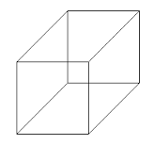  A 3D shape

