Name: ____________________________
Homework (WEEK 3) Honors:
TRY YOUR BEST AND SHOW ALL OF YOUR WORK! Use CUBES (circle, underline, box, evaluate, and solve) to earn full credit.
MONDAY:
Solve the following problems without a calculator. You MUST show your work. NO WORK = NO CREDIT.
1. Oka had $12. Then she saved $15 from her allowance. She bought 5 blow pops for $.25 each, 24-tootsie rolls for $.03 each, and 2 airheads for $.60 each. How much money did Oka spend and how much does Oka have left?  Answer________ | 2. Write the following in exponential form and  evaluate:  A. 6 x 6 x 6 x 6 x 6 = ____=_____  B. 5 x 5 x 5 x 5 =____=_____  C. 12 x 12 = ____=_____
3. A group of 1,176 campers wants to take boats out on the lake. If each boat holds 12 campers, how many boats will the campers need?  Answer________  4. SAT Question: If 3^{x-2} =3, then x= 3  Answer_______ | - 173 x 43 =  Answer________  - SAT Question: If 2⁴= 4^{x}, then  Answer________

TUESDAY
Solve the following problems without a calculator. You MUST show your work. NO WORK = NO CREDIT.
1. Each question on a game show is worth 15 points. Last night, a contestant answered 268 questions correctly. How many points did the contestant earn?  Answer________  1a. Evaluate: 5² · 5 ÷ 5 + 5²  Answer________ | 2. Evaluate: 5² ÷ (25 ÷ 5) ²  Answer________  3. 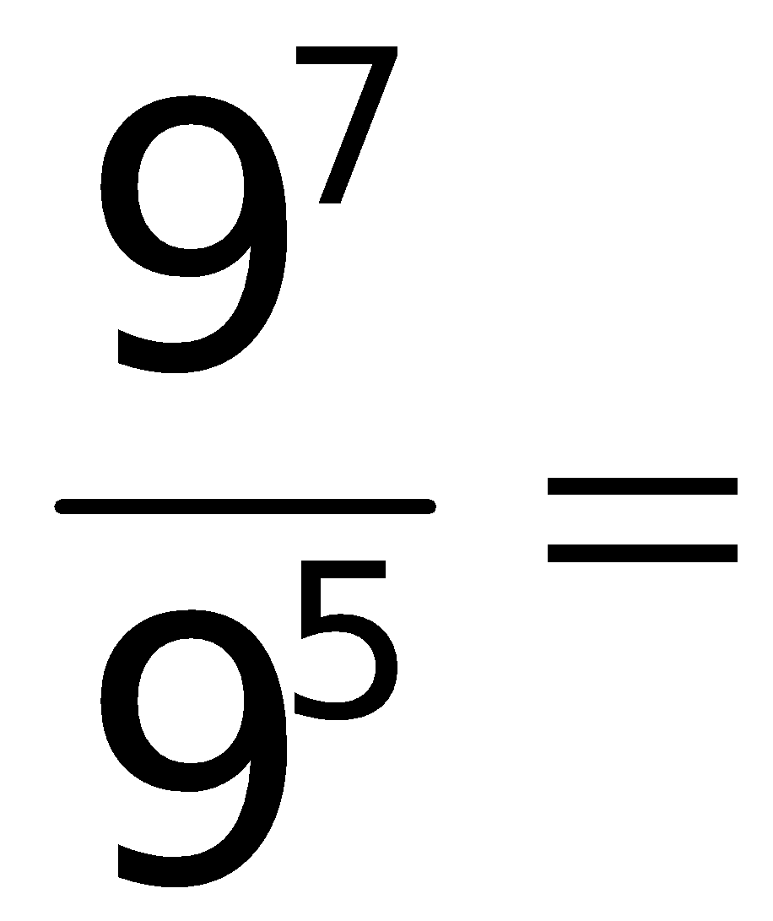 __________  Describe the rule for dividing exponents with the same base  Answer_______________________________
4. Evaluate:  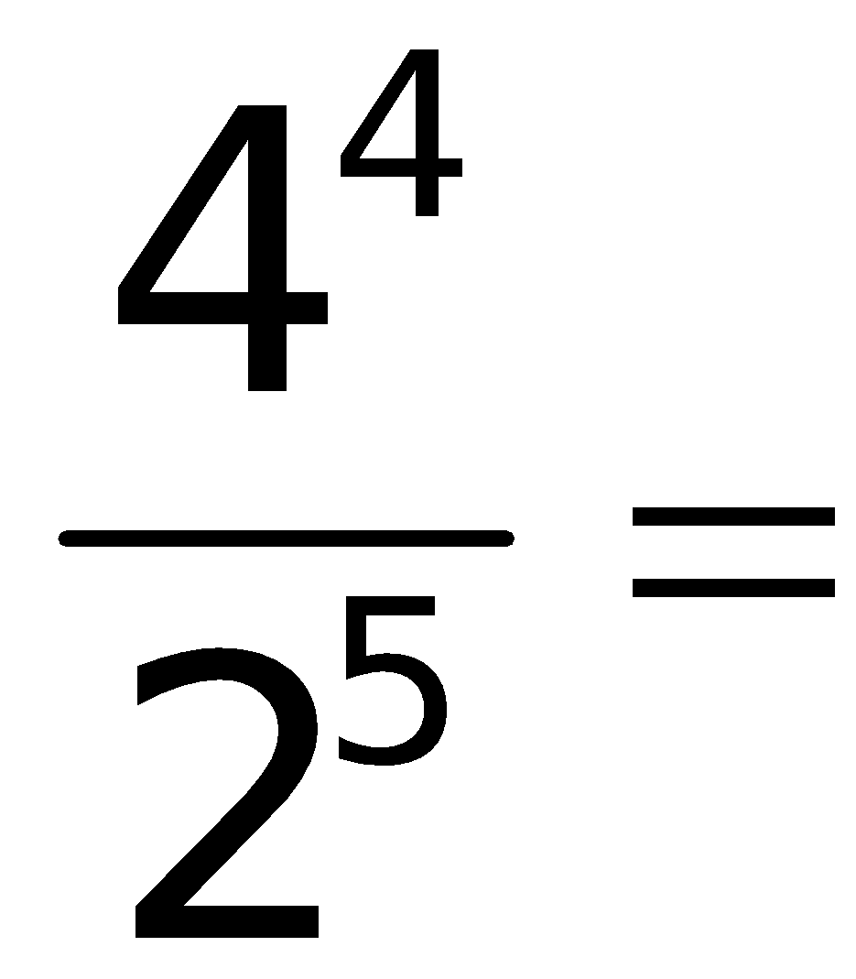 __________  Can you use the rule for dividing exponents for this problem? Explain why or why not?  Answer________________________________ | 5. Look at the following number:  87341.32  What number is in the hundredths place? ______  What number is in the hundreds place? _______  What number is in the tenths place? ______  What number is in the ten thousands place? _____
WEDNESDAY
Solve the following problems without a calculator. You MUST show your work. NO WORK = NO CREDIT.
1. 79,325 ÷ 24 =  Answer________ | 2. Write in expanded form and solve.  a) 6⁴ = ______________=_____  b) 3⁵ = ______________=_____  c) 132⁰= ______________=_____  d) 25545¹= ____________=_____
3. 268 miners need to ride the elevator to the bottom of the mine. The elevator can hold 17 miners at a time. How many miners will be in the elevator on its last trip?  Answer________  - Solve.  (6•4÷3) ² – (2⁴ – 5 •2) ÷ (2² ÷ 2¹) +2234⁰  Answer________ | 5. Solve.  (6 • 3 – 8)² ÷ 4(5² ÷ 5) ⁰ + 5(5²)  Answer________
THURSDAY
Solve the following problems without a calculator. You MUST show your work. NO WORK = NO CREDIT
- Evaluate:  (199⁰ • 9²)  3(3³ ÷ 3)  Answer________ | 2. Try your luck at these analogy puzzles. An analogy compares two things to two others. Here is example:  9 : 10 : : 81 : ?  This is read as “9 is to 10 as 81 is to …” and the answer is 100.  9² = 81  10² = 100  Now find the missing numbers or words in the following analogies:  a. 11 : 121 : : 20 :  b. 3 : 27 : : 4 :
3. Solve.  (9⁰ + 3) ⁰ + 5(72 ÷ 9 + 2) + 12  Answer________ | - Solve.  12² – 5(3 • 3 + 3) =  3  Answer________

